**Moulik Tammana**

**Q5. Set up trunk ports between switches and try ping between different VLANs.**

**The below network is connected using VLAN. We have configured 2 VLAN’s in each switch.**

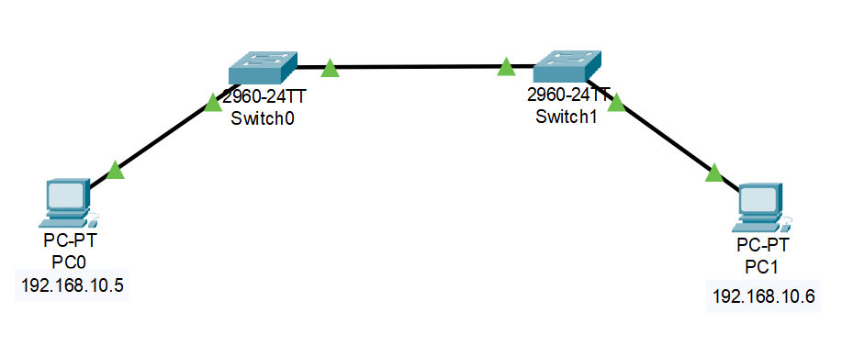

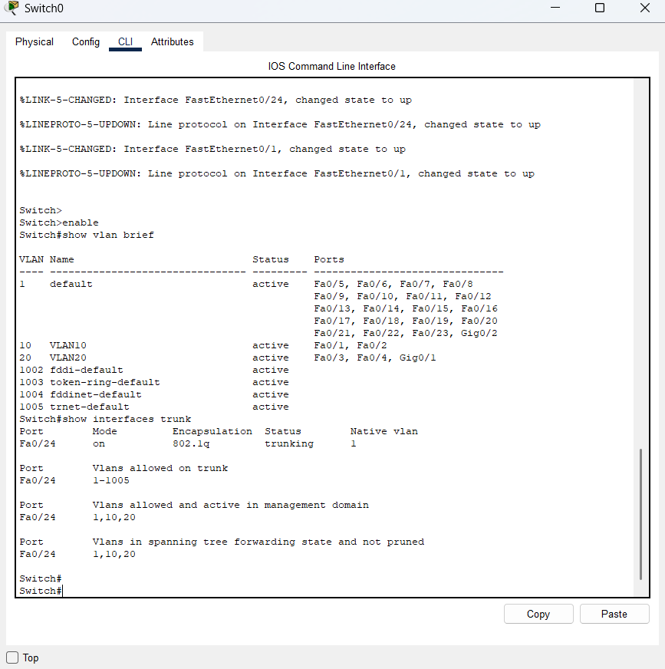

**Created 2 VLANs in each switch and configured all the VLAN’s to the same trunked port with is assigned to port Fa0/24. Assigned port Fa0/1 and Fa0/2 to VAN 10 and Fa0/3 and Fa0/4 to VLAN 20. Also set the Native VLAN as VLAN 1 which is the default VLAN.**

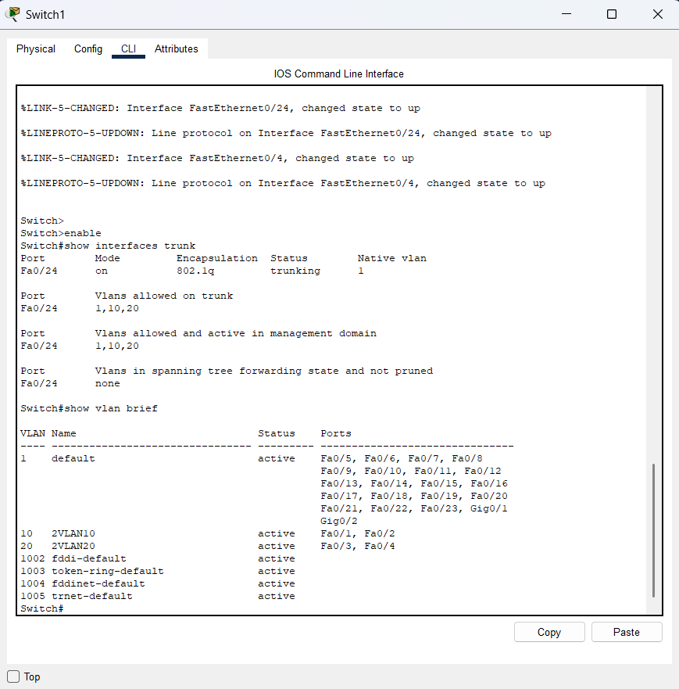

**We have connected both the switches to trunk ports.**

**The below was the case when the ping was successful when we connected, we connect both the PC’s to the VLAN with the same ID. For devices to be able to ping each other within the same VLAN, they must be assigned the same VLAN tag (ID)**

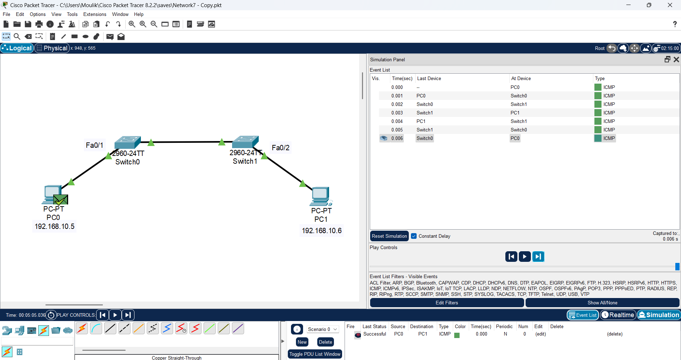

**This is the case when the ping fails to work between both the PC’s as the PC’s as connected to the switch of different VLAN tags.**

